QR kódy tras
7 km
https://mapy.com/s/fajagetebu
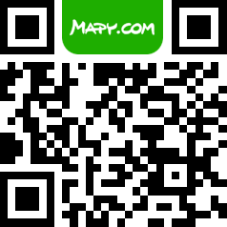

15 km
https://mapy.com/s/jutabeloda
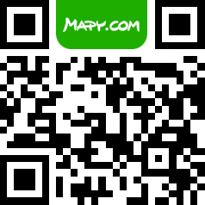

25 km
https://mapy.com/s/huduhodacu
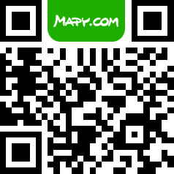

33 km
https://mapy.com/s/jutacarago
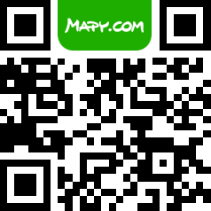

44 km
https://mapy.com/s/cohohupujo
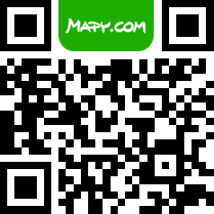

50 km
https://mapy.com/s/burejudalo
